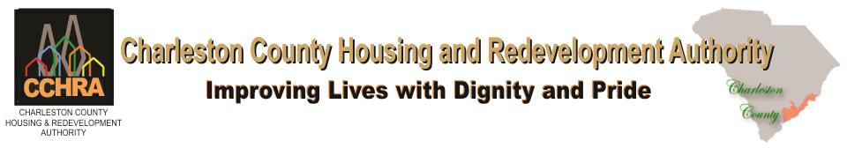

Regular Meeting

Board of Commissioners

Mission: Our MISSION is to provide quality affordable housing and assist in improving economic opportunities for the low-income citizens of Charleston County.

Wednesday April 27, 2022

The Board of Commissioners of the Charleston County Housing Authority will hold its Regular Meeting on Wednesday, April 27, 2022 at 12:00 PM

The Meeting will conduct via Zoom

*Board Members

Sandino Moses, Board Chair
Patrick King, Vice Chair
Lane Boris, Commissioner
Chris Nungesser, Commissioner
Cathryn Davis, Commissioner
Betty Gonzalez, Commissioner
Curtis Thompson, Commissioner
Charleston County Housing & Redevelopment Authority

Regular Board of Commissioners Meeting
April 27, 2022, at 12:00 PM
Agenda

- Call To Order (Time)
- Prayer
- Roll Call and Introduction of Guests
- Visitors

- Approval of Minutes (Approved – Not Approved)
March Meeting Minutes

- BOC Report
  - JFM Residential Meeting
  - Brighton Place Residential Meeting

- CEO Report

- Administration Reports
  - Public Housing and Maintenance (PH/MNT) Report
  - HCV Report
  - Finance Report

- Committee Reports
  - Finance Committee
  - Personnel Committee
  - Construction/Facilities Committee
  - Community Engagement Committee

- Executive Session
10.1 Annual Plan

- Resolution 2022-04
  - Annual Plan 2022

- Adjournment Time _________________

